ONITA
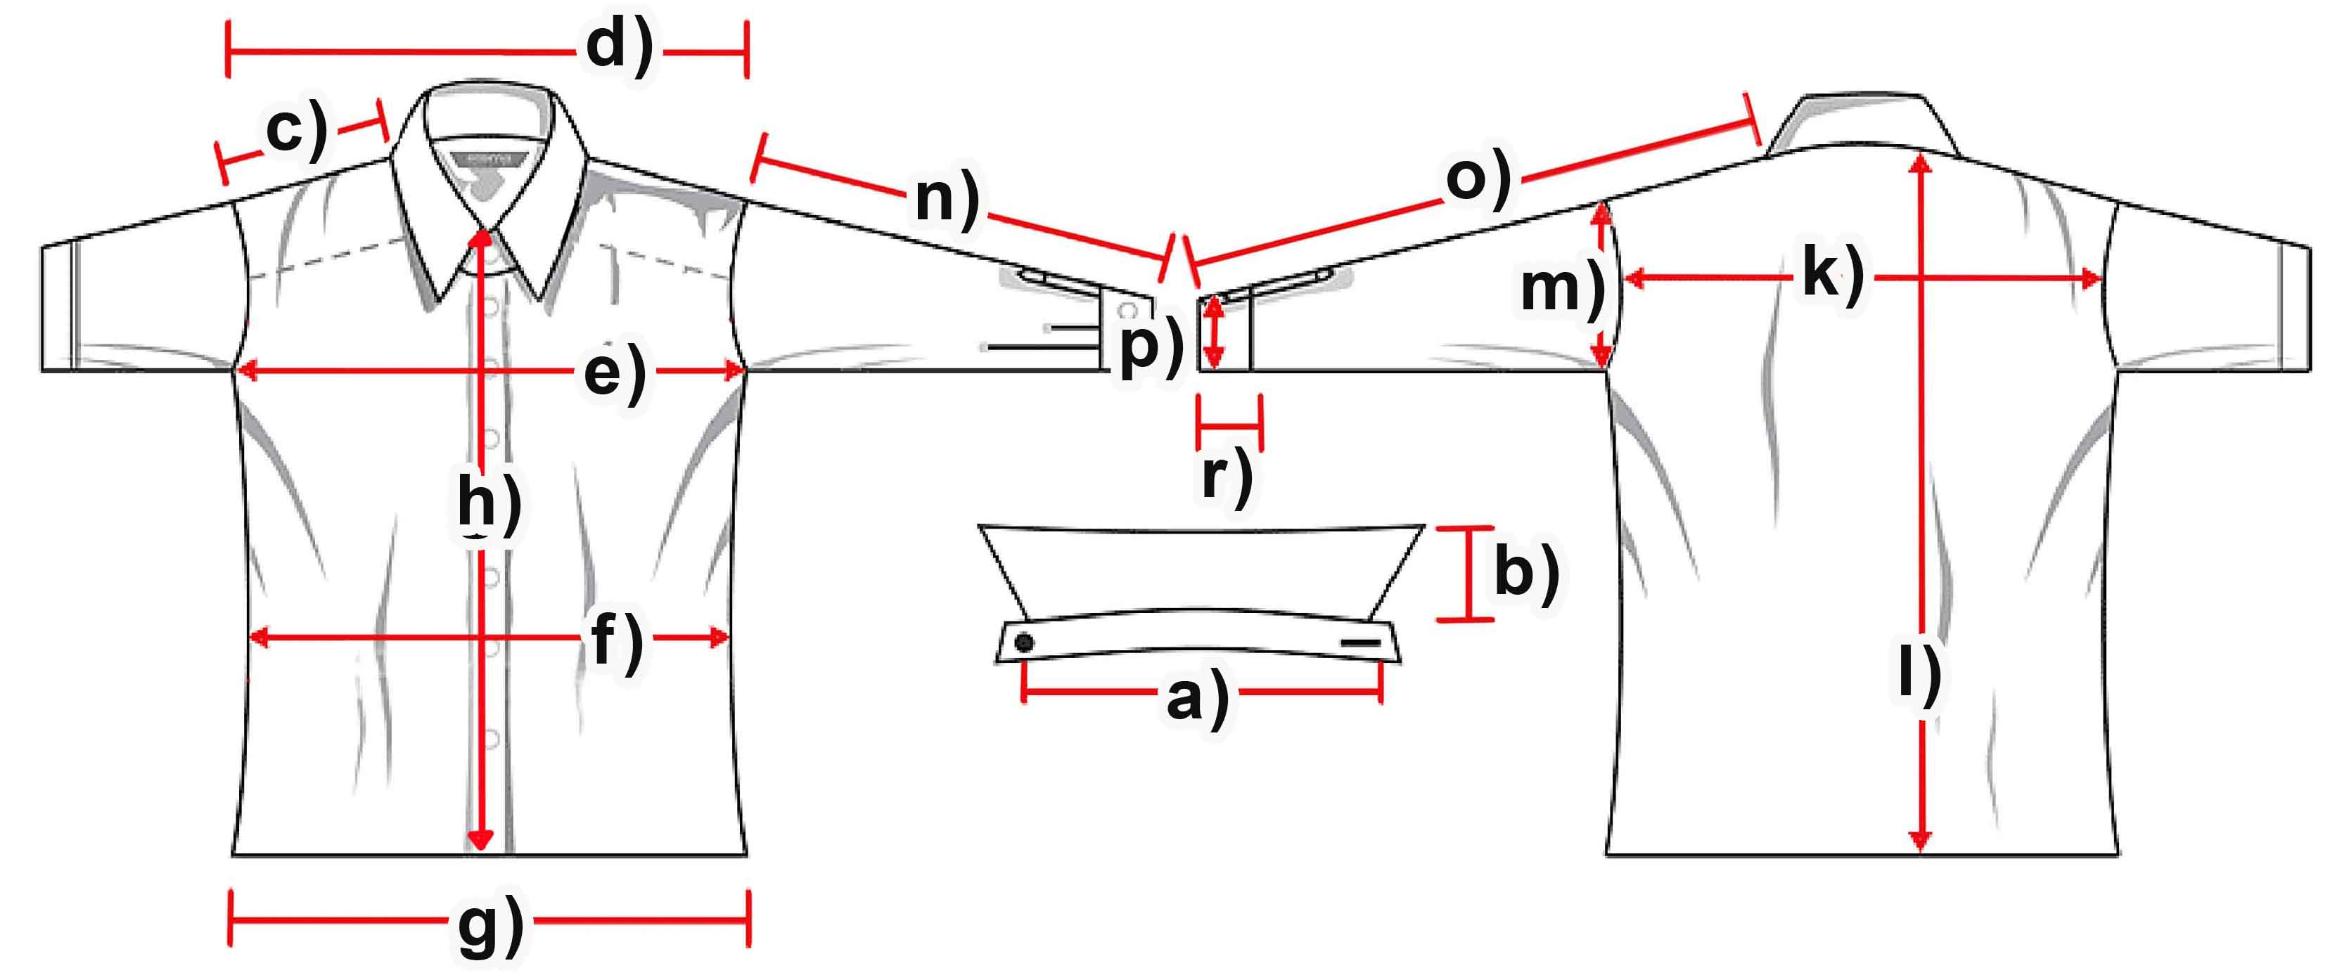

Measure (cm) | XS | S | M | L | XL | XXL | 3XL
a) Collar width
b) Collar height |  | 6,5 | 7 | 6,5 | 6,5 | 6,5 | 6,5
c) Shoulder |  | 10,5 | 11 | 11 | 11,5 | 11,5 | 11,5
d) Shoulders total |  | 38,5 | 39,5 | 39,5 | 41 | 42,5 | 43
e) Chest |  | 48,5 | 50,5 | 53 | 54,5 | 56 | 58
f) Waist |  | 42,5 | 44 | 46,5 | 48 | 50 | 52,5
g) Hem |  | 58,5 | 61 | 63 | 65 | 66 | 68
h) Placket |  | 77,2 | 78 | 78 | 78,5 | 79,5 | 78,5
k) Back width |  | 36 | 37 | 37 | 39,5 | 40,5 | 41,5
l) C.B length |  | 84 | 85 | 86 | 88 | 87,5 | 88
m) Armhole |  | 25,5 | 27 | 28 | 29,5 | 30,5 | 32
n) Arm length |  | 64,5 | 64 | 64 | 65 | 65,5 | 66,5
o) Arm + Shoulder |  | 75 | 75 | 75 | 76,5 | 78 | 78
p) Cuff width |  | 13,5 | 14,2 | 14,5 | 15 | 15,5 | 16
r) Cuff height

